Technical Design Document

Download option from Document List, Minified Document List & Document Viewer

Table of Contents

Download option from Document List, Minified Document List & Document Viewer 2

Technical Story 1.1: create the api method to allow the download of multiple workflow items/documents. 2

Technical Story 1.2: Change Route “GetDocumentTypesByHostApplicationLocalDataId” in document type controller. 3

Technical Story 1.3: Add Route to get the document type for a document id. 3

CLIENT SIDE CHANGES 3

Technical Story 2.1: Download button shouldn’t be visible to the user if user isn’t View rights on the Document Type (Document List & Minified Document List) 3

Technical Story 2.2: Download button shouldn’t be visible to the user if user isn’t View rights on the Document Type (Embedded/Standalone Document Viewer) 3

Technical Story 2.3: Download Button Enable/Disable on Document Selection (List) 4

Technical Story 2.4: Downloading the content 4

Technical Story 2.5: Naming Convention for downloaded file 4

MOCK UP: 4

QA Notes: 6

Download option from Document List, Minified Document List & Document Viewer

*As a PaperSave user, I may need the ability to download documents either from Document List, Minified Document List or from Document Viewer*

[*FD_Download option from Document List, Minified Document List & Document Viewer.docx*](https://operations.cloud.papersave.com/PaperSave.WebModule/DocumentDisplay.aspx?DocIDs=260865)

## Technical Story 1.1: create the api method to allow the download of multiple workflow items/documents.

* Action: POST
* Route: api/documents/downloadcontent/layers/{true/false}
* Return Type: ActionResult
* Body: [1,2,3] (Array of Document Ids) (We’ll always pass document id)
* Response:

Should return the file to download.

* Following business rule validation should be done before content for a document can be downloaded successfully.
  + If the Document ID is of Workflow Item
    - Check User has view rights
    - Check User is Workflow Admin
    - Check User is Super user.
    - If any of this condition is true, it is ok to return the content.
  + If the Document Id is of Document
    - Check User has view rights on Document Type
* If any of the security validation fails, then that document should be skipped from the list.
* If security validation is successful then if only single file is requested we should return it using following.

return File(bytearray, System.Net.Mime.MediaTypeNames.Application.Octet, "{FileName} ");

* Else we should create the zip file and return it.
* Refer to the “DownloadFile.ashx.cs” code for creation of the zip.
* File Naming should be as per the functional document.

Technical Story 1.2: Change Route “GetDocumentTypesByHostApplicationLocalDataId” in document type controller.

* Change the route to following.
  + Api/DocumentTypes/HostApplicationLocalData/{HostApplicationLocalDataID}
* Change the datatype of “HostApplicationLocalDataID” from integer to long.
* And implement security (if not already implemented) to return a document type only if the user has view rights on the document type.

Technical Story 1.3: Add Route to get the document type for a document id.

* Add the following route.
  + Api/DocumentTypes/DocumentType/{DocumentD:long}
* And implement security to return a document type only if the user has view rights on the document type.

### CLIENT SIDE CHANGES

Technical Story 2.1: Download button shouldn’t be visible to the user if user isn’t View rights on the Document Type (Document List & Minified Document List)

* As we are only retrieving the document type that user has view rights on, we don’t need to put a check to conditionally show download button.
* We should show the download button always.
* Of course, if user tweaks manually client side then they may end up viewing the download button for the document type that they are not supposed to view but the server side check won’t allow them to perform the operation.

Technical Story 2.2: Download button shouldn’t be visible to the user if user isn’t View rights on the Document Type (Embedded/Standalone Document Viewer)

* It should make the call to the route “api/documenttypes/document/{documentid}.
* And if the “HasViewRightsPrinciple” on the returned document type is false, then it should show the message to the user that user doesn’t have view rights. And should proceed loading the document.
* Else we should load the document display and the download button should be visible and enabled.

Technical Story 2.3: Download Button Enable/Disable on Document Selection (List)

* When user has view rights, we should show the button in the action panel. (Disabled)
* When any item is selected, we must be maintain a list of selected items.
* The enable/disable of the download button in the action panel should be bind to the count of the item in the list of selected item.
* So enable/disable of the delete button will work properly based whether the item is selected or not.

Technical Story 2.4: Downloading the content

* When download button is clicked, it should call the above API and pass necessary parameters.
* This should be asynchronous call.
* The result of this call will start the download of the content.

Technical Story 2.5: Naming Convention for downloaded file

* When a single file is downloaded then the filename pattern should be as following.
  + ID + “- “ + CURRENT DATE AND TIME (DateTime.Now.ToString("yyyyMMdd-HHmmssff"))
* When multiple files are downloaded then the filename pattern should be as following
  + The name of the zip file should be “Documents of [DocumentTypeName] document type -“ + CURRENT DATE AND TIME. (Please make sure to remove any special character from document type name that isn’t allowed in filename.)
  + Each document’s name within the zip file should have the below naming convention:

ID + “ - “ + CURRENT DATE AND TIME

MOCK UP:

Download option in Document List.

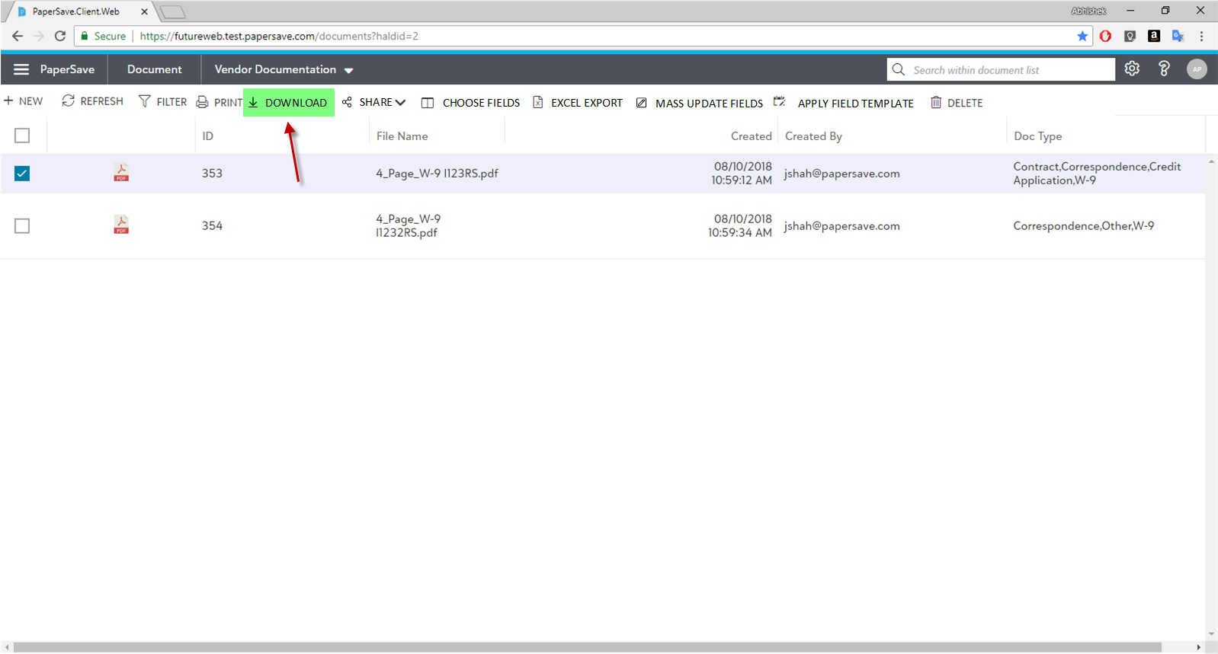

Download option in minified document list.

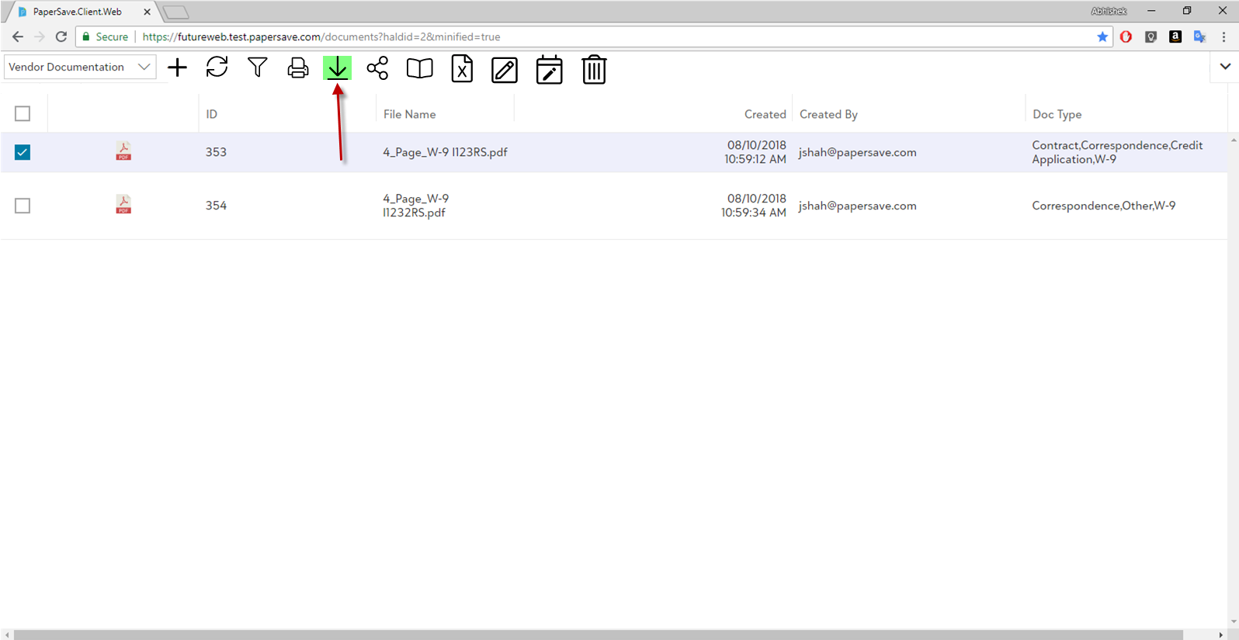

QA Notes:

* We won’t be showing any notification for download at the moment. There is a technical limitation at the moment.
* Test the download of password protected pdf files.
* Audit log isn’t implemented.